# While Loops

## Question: 1

Why do we use while loops?

To repeat code a specific number of times

To use if-else statements in a loop

To repeat code when the number of times to repeat is unknown

To determine if a condition is true

## Question: 2

How is an infinite loop created?

By using an infinite value in a for loop

By using an infinite value in a while loop

By using a condition that will never become false in a for loop

By using a condition that will never become false in a while loop

## Question: 3

What will happen when this code is run?

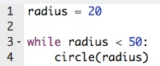

Tracy will draw 1 circle with a radius of 20.

Tracy will draw 50 circles with a radius of 20.

Tracy will draw 20 circles with a radius of 50.

An infinite loop will occur.

## Question: 4

What will the output of the following code be?

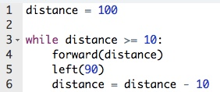

1. 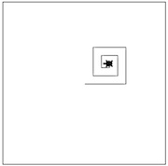
2. 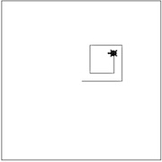
3. 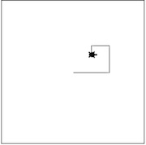
4. An infinite loop will be created.

Creating the Canvas

# Question: 1

Which of the following points is horizontally lower than the point (100, 100) on the canvas?

1. (100, 200)
2. (200, 100)
3. (50, 100)
4. (100, 50)

# Question: 2

Which of the following programs will not create a 200x200 blue canvas?

from tkinter import *

root = Tk()

screen=Canvas(root, width = 200, height = 200, background = 'blue')

screen.pack()

mainloop()

from tkinter import *

root = Tk()

screen=Canvas(root, width = 200, height = 200, bg = 'blue')

screen.pack()

mainloop()

from tkinter import *

root = Tk()

screen=Canvas(root, width = 200, height = 200, color = 'blue')

screen.pack()

mainloop()

# Question: 3

What will the resulting canvas look like when the following program is run?

from tkinter import *

root = Tk()

screen=Canvas(root, width = 200, height = 200)

screen.pack()

screen.create_line(0, 0, 100, 100, 200, 0)

mainloop()

1. 
2. 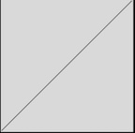
3. 
4. 